College of Arts & Sciences
Geology (BS)

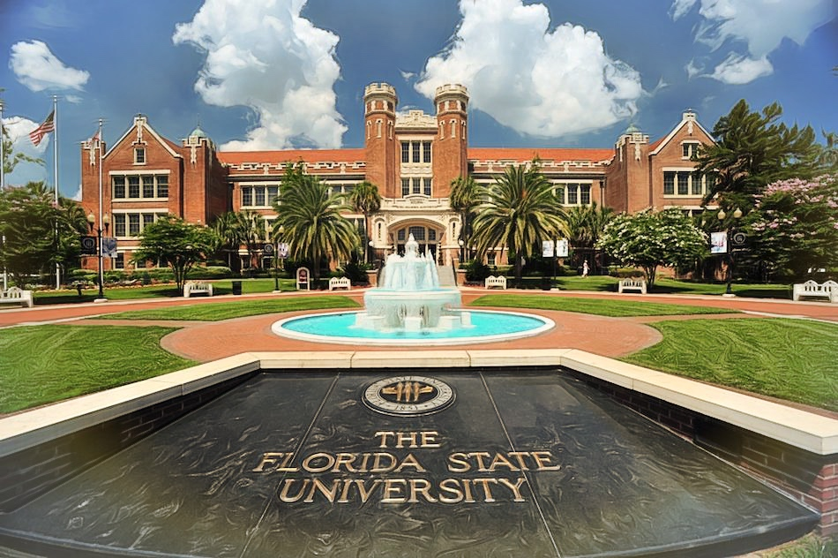
Admission | Information
- Limited Access – No | - Minimum GPA = 2.00 overall
- Limited Enrollment - No | - Test Required – No
- Separate Major Application Required – No | - Admits every semester

** This is a recommended sequence of courses for general advisement purposes only. Students are encouraged to meet with their academic advisor**

Required Pre-Requisite Courses
(C minus or higher required in each course)

FSU COURSES TCC COURSE EQUIVALENT
MAC1105 College Algebra MAC1105
MAC1140 Pre-Calculus MAC1140
MAC1114 Trigonometry MAC1114
CHM1045 General Chemistry I + Lab CHM1045/L
CHM1046 General Chemistry II + Lab CHM1046/L
GLY2010c Physical Geology w/Lab GLY2010/L
MAC2311 Calculus I recommended MAC2311

YEAR 1 TCC
FALL | SPRING
ENC1101 (3) | ENC 1102/ENC1141 (3)
State Core Math, Area A:  MAC1105 (3) | TCC Core Math, Area B:  MAC1140 (3)
State Core Soc Sci, Area A, Group 1 (3) | CHM1045 + CHM1045 Lab (NSLab)* (4)
TCC Core Soc Sci, Area B, Group 2:  SLS1510 or SLS2261 (3) | State Core Humanities, Area A:  THE2000 recommended (Div)* (3)
State Core Soc Sci, Area A, Group 2:  AMH2020 or POS1041 (Civ Lit)* (3) | Modern Language I recommended (4)
Total: 15 | Total: 17

YEAR 2 TCC
FALL | SPRING
MAC1114 (3) | MAC2311 recommended (5)
CHM1046 + CHM1046 Lab (4) | GLY2010 + GLY2010 Lab (4)
TCC Core Soc Sci, Area B, Group 1 (3) | Modern Language III recommended (4)
TCC Core Humanities, Area B:
HUM2210 recommended (SIP)* (3)
Modern Language II (4)
Total: 17 | Total: 13
*FSU Graduation Requirement: Civ Lit = Civic Literacy, NSLab = Natural Science Lab, Div = Diversity, SIP = Scholarship in Practice

Total Credits: 62

Transfer to the University Information

Website: https://admissions.fsu.edu/transfer/
Email: admissions@fsu.edu
Phone: (850) 644-6200
Address: Florida State University
Office of Admissions
A2500 University Center
282 Champions Way
Tallahassee FL 32306-2400

Major Information

FSU College of Arts & Sciences: https://artsandsciences.fsu.edu/
Department of Earth, Ocean & Atmospheric Science (EOAS): https://www.eoas.fsu.edu/
Geology Program: https://www.eoas.fsu.edu/undergrad-degrees/geology/
Email: Eoas-advising@fsu.edu

Employment Information

FSU Career Center: https://www.career.fsu.edu/

Representative Job Titles Related to this Major: Geologist, Geochemist, Earth Scientist, Geophysicist, Marine Geologist, Hydrologist, Oceanographer, Environmental Administrator, and Paleontologist.

Representative Employers: Mining Companies, Petroleum Companies, Consulting Firms in Environmental Sciences, U.S. Agencies (Geological Survey, Bureau of Mines, Dept. of Agriculture, EPA, Nuclear Regulatory Commission), State Agencies.

