College of Communication & Information
Information, Communication & Technology (BS)

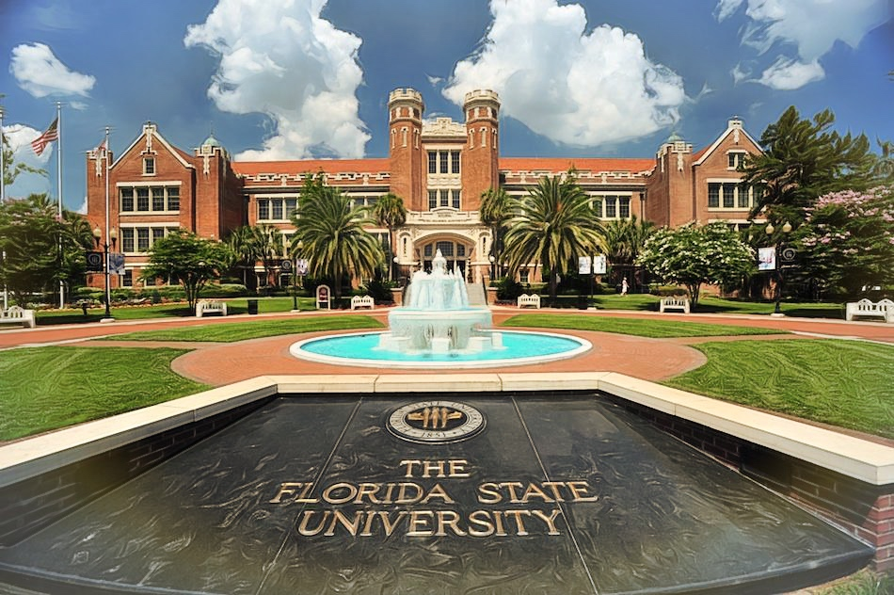
Admission | Information
- Limited Access – No | - Minimum GPA = 2.00 overall
- Limited Enrollment - No | - Test Required – No
- College Application Required – No | - Admits every semester

** This is a recommended sequence of courses for general advisement purposes only. Students are encouraged to meet with their academic advisor**

Required Pre-Requisite Courses
(C minus or higher required in each course)

FSU COURSES TCC COURSE EQUIVALENT
PSY2012 General Psychology PSY2012
STA2xxx Statistics STA2023/2122
MAC1140 Pre-Calculus MAC1140
ECO2013 Macroeconomics ECO2013
PHIxxxx Philosophy PHI2010/2100/2600
LIS2780 Database Concepts CGS2540
LIS2360 Programming COP2200
COP2258 Object-Oriented Programming COP2800*

*COP2200 is a required pre-requisite to COP2800 at TCC

YEAR 1 TCC
FALL | SPRING
ENC1101 (3) | ENC 1102/ENC1141 (3)
State Core Math, Area A:  MAC1105 suggested (3) | MAC1140 (3)
PSY2012 (3) | State Core Soc Sci, Area A, Group 2:  AMH2020 or POS1041 (Civ Lit)* (3)
TCC Core Soc Sci, Area B, Group 2:  SLS1510 or SLS2261 (3) | State Core Humanities, Area A:  THE2000 recommended (Div)* (3)
State Core Nat Sci & matching Lab, Area A  (NSLab)* (4) | CGS2574 (3)
Total: 16 | Total: 15

YEAR 2 TCC
FALL | SPRING
STA2023 or 2122 (3/4) | SPC1017/2608 (OC)* (3)
TCC Core Humanities, Area B:  HUM2210 recommended (SIP)* (3) | TCC Core Nat Sci, Area B (3)
TCC Core Soc Sci, Area B, Group 1 (3) | PHI2010 or 2100 or 2600 (3)
COP2200 (3) | COP2800 (3)
ECO2013 (3) | A.A. Elective (3)
Total: 15/16 | Total: 15
*FSU Graduation Requirement: NSLab = Natural Science Lab, Civ Lit = Civic Literacy, Div = Diversity, SIP = Scholarship in Practice, OC = Oral Competency

Total Credits: 61/62

Transfer to the University Information

Website: https://admissions.fsu.edu/transfer/
Email: admissions@fsu.edu
Phone: (850) 644-6200
Address: Florida State University
Office of Admissions
A2500 University Center
282 Champions Way
Tallahassee FL 32306-2400

Major Information

FSU College of Communication & Information: https://cci.fsu.edu/
School of Information: https://comm.cci.fsu.edu/
Admission to major: https://ischool.cci.fsu.edu/programs/undergrad-programs/information-technology/#admissions
Email: advising@cci.fsu.edu

Employment Information

FSU Career Center: https://www.career.fsu.edu/

Representative Job Titles Related to this Major: Web Designer, Digital Marketing Manager, Social Media Manager, Technical Editor/Writer

Representative Employers: IT Businesses, Business and Professional Associations, Public Relations Firms, Communication Firms, Research Organizations, Universities and Colleges, Consulting Firms, Information Industry (Publishers and other media outlets), Planning Agencies, Government Agencies.

